**ASSIGNMENT#1 -REPORT**

**Group Member 1:**

**Group Member 2:**

**Part 1. Algorithm analysis and recursion**

1. **(20 pts)**

If *T(n) = T(n/2) + 2n* and *T(1)=1* then,

Paste the picture of the step by step solution.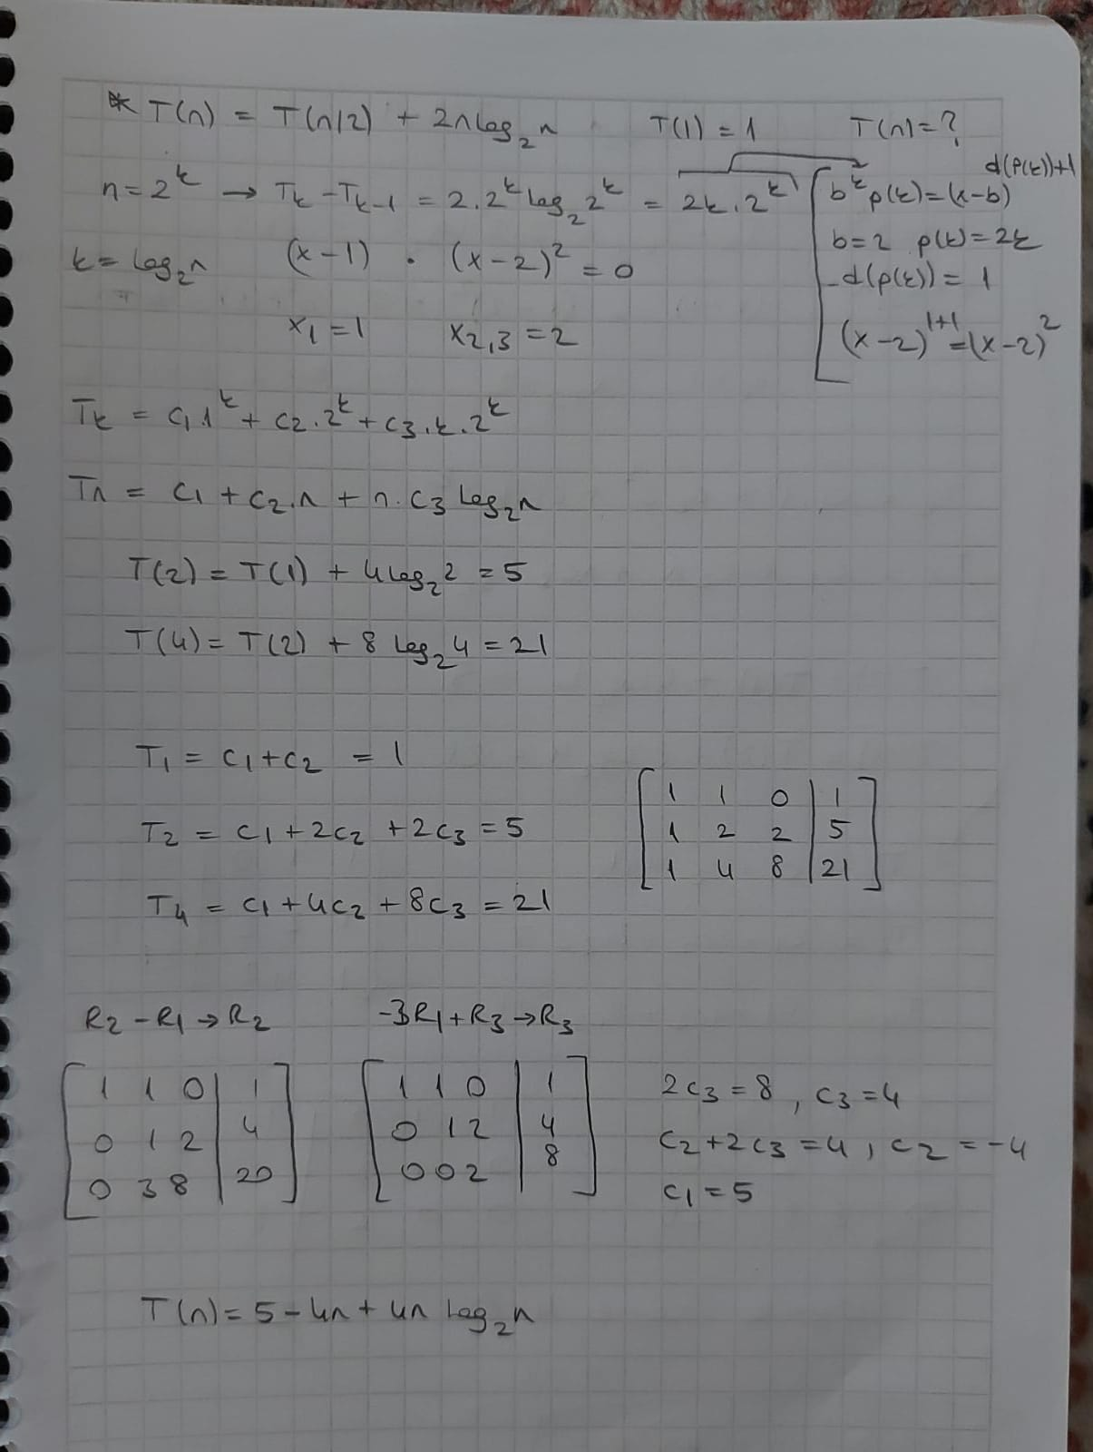

1. **(15 pts)**

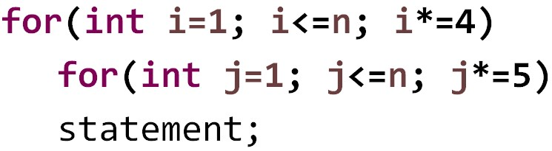

Paste the picture of the step by step solution.

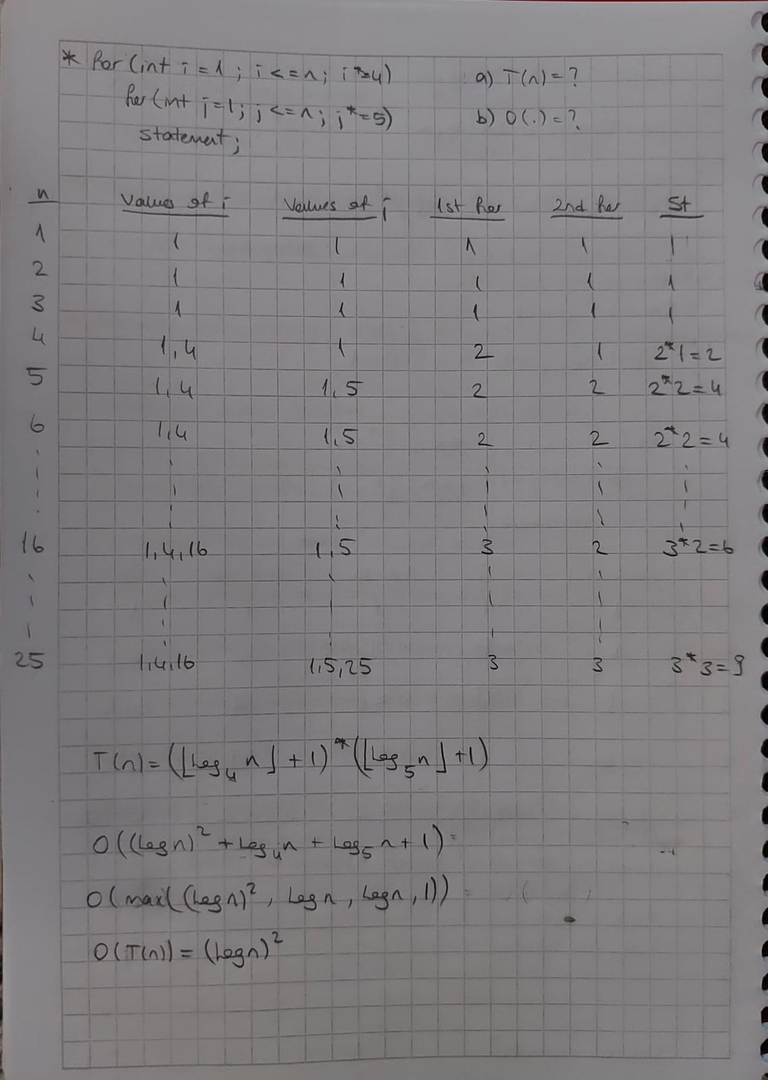

**Part 2.**

* Movie records must have the following properties:

Paste the code of your movie struct or class.

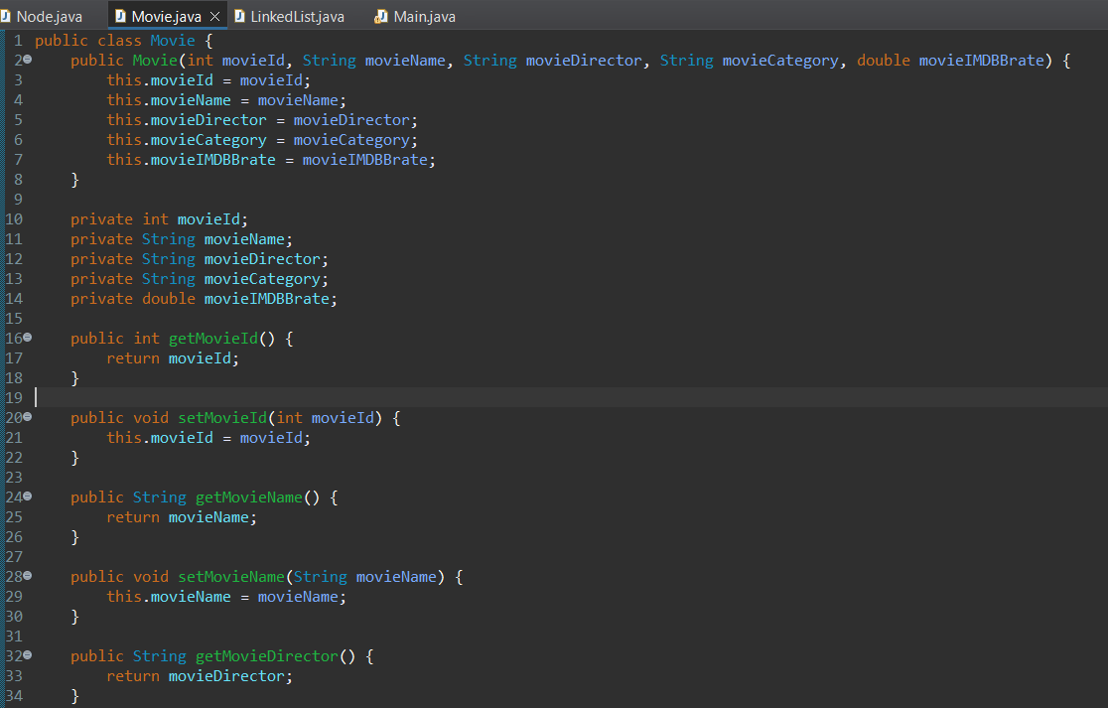

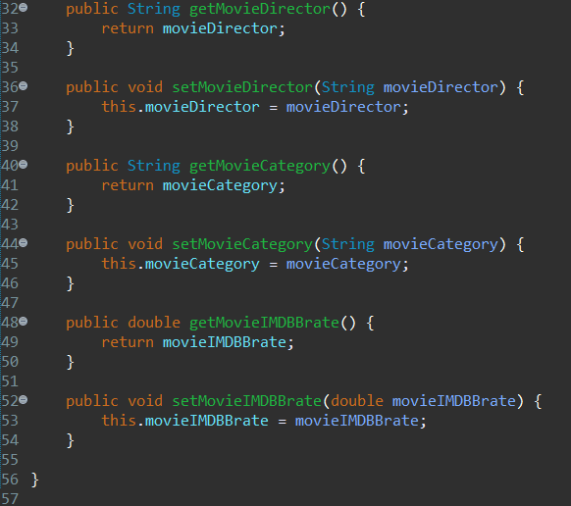

* Your program must have a main menu including the following commands:
* Add a new movie:

Paste the insert code fragment(method or function) of your project.

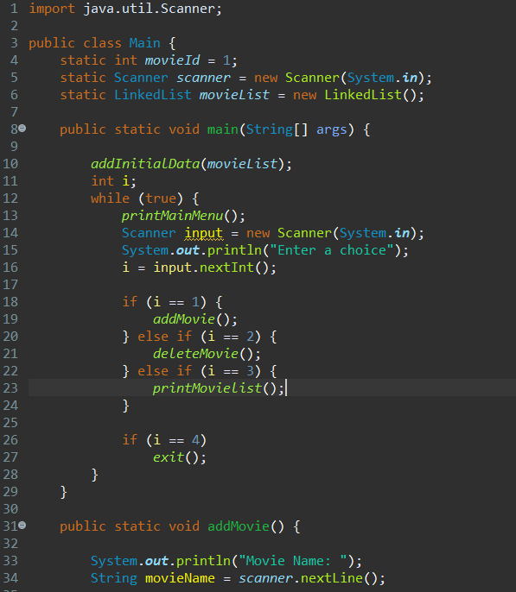

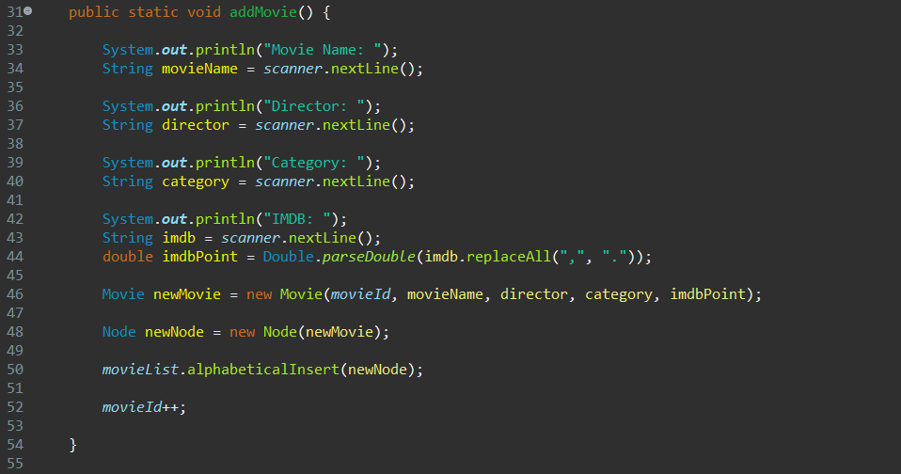

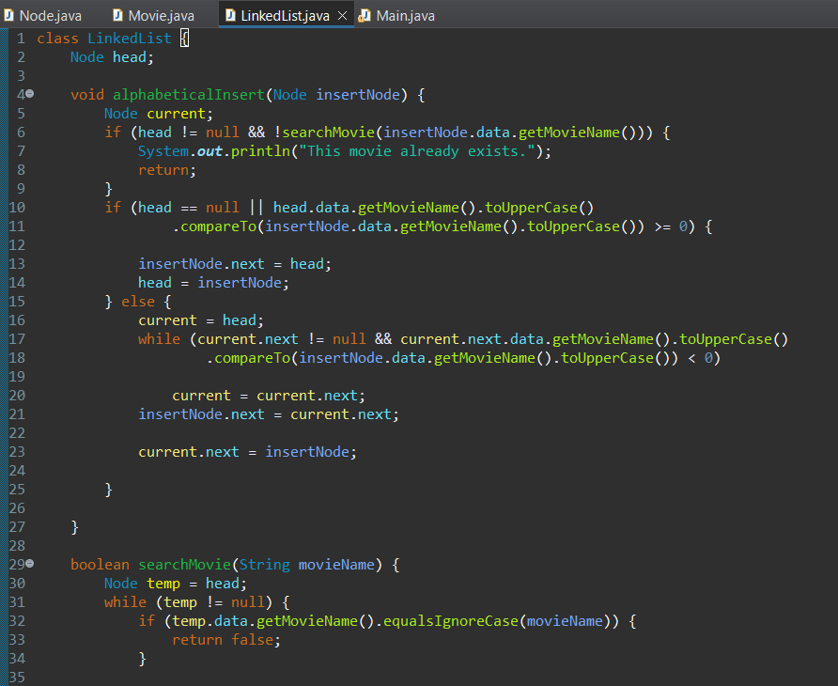

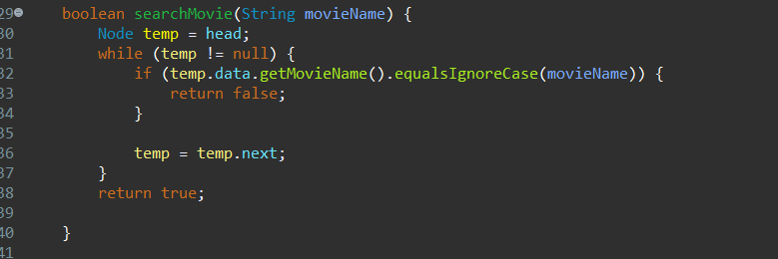

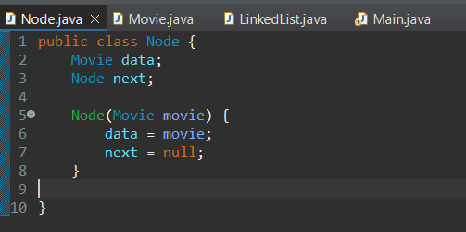

Paste a screenshot that adds a record to an empty list and print the list.

Paste a screenshot that adds a record to the head of a non-empty list and print the list.

Paste a screenshot that adds a record to the end of a non-empty list and print the list.

Paste a screenshot that adds a record to somewhere in middle in a non-empty list and print the list.

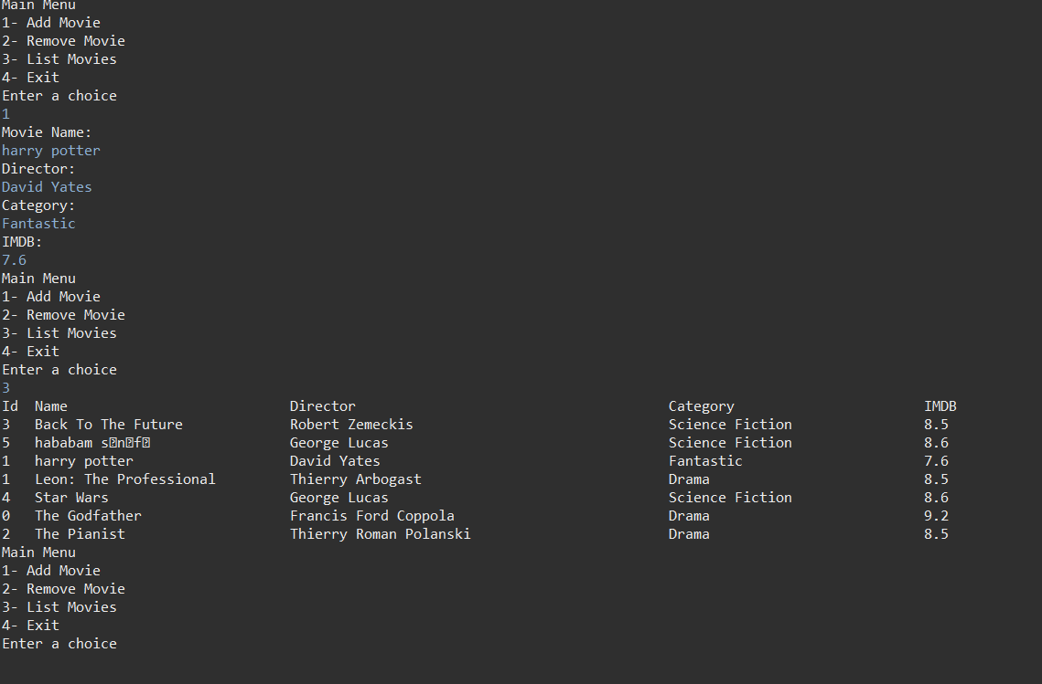

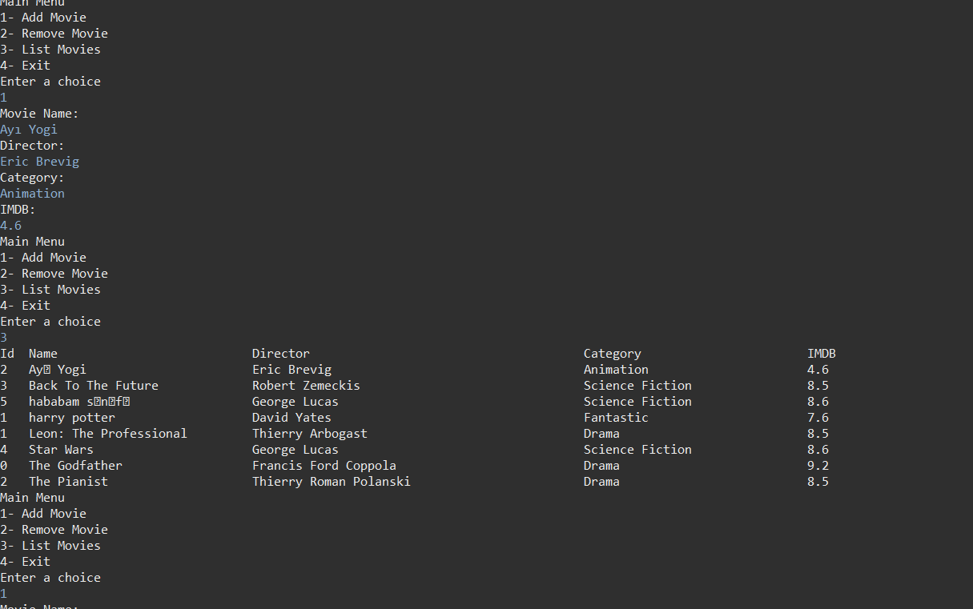

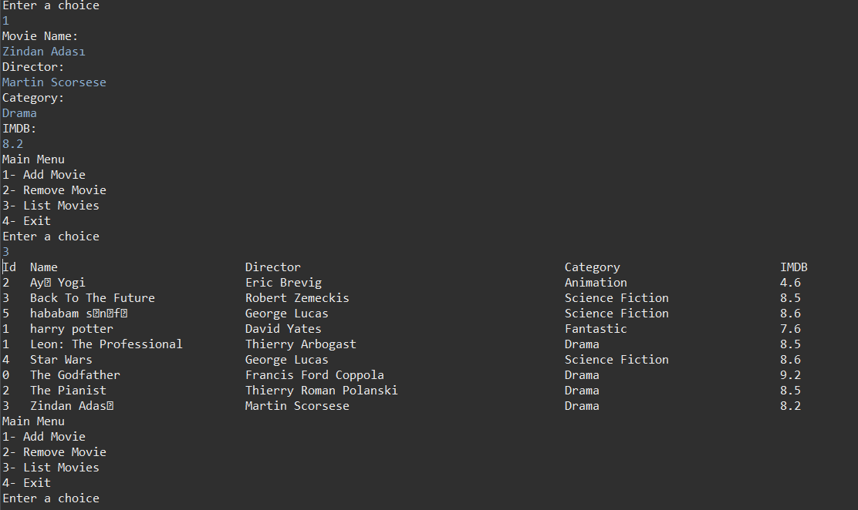

* Remove a movie:

Paste the remove code fragment(method or function) of your project.

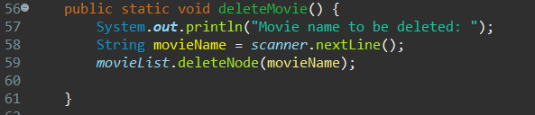

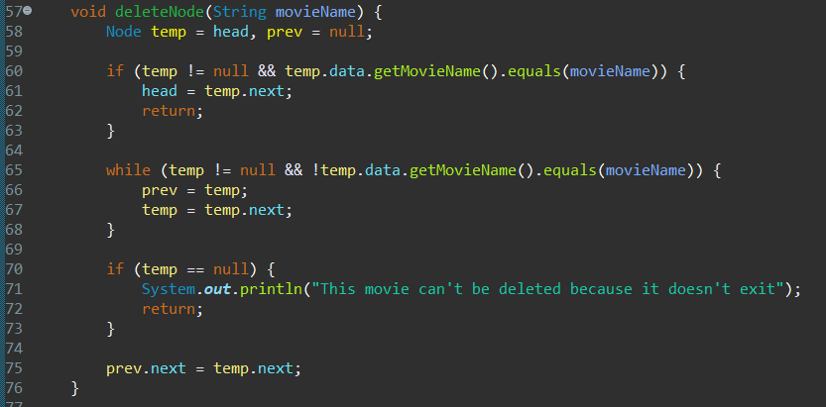

Paste a screenshot that removes a record from a non-empty list and print the list.

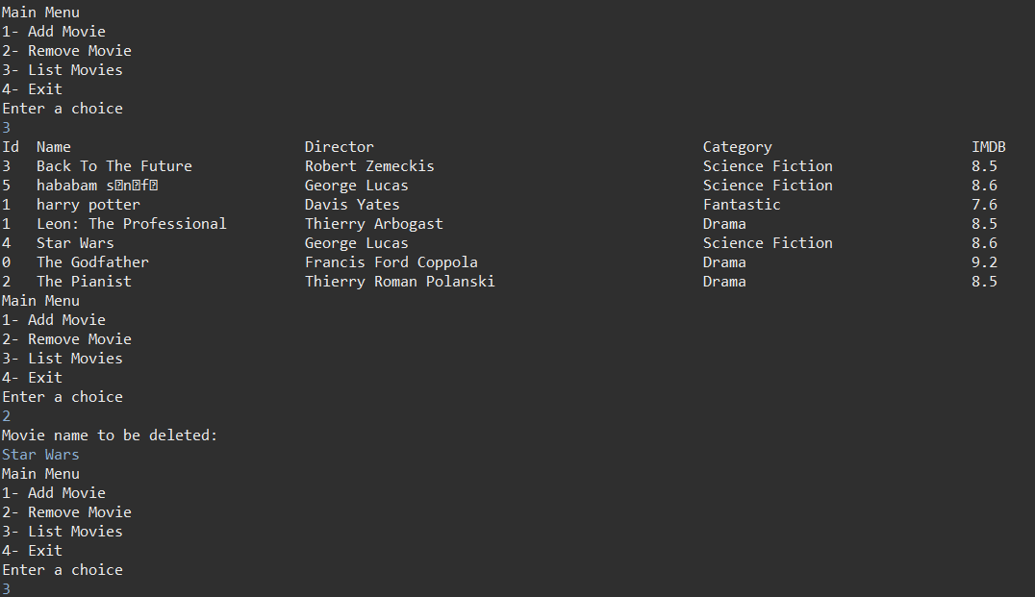

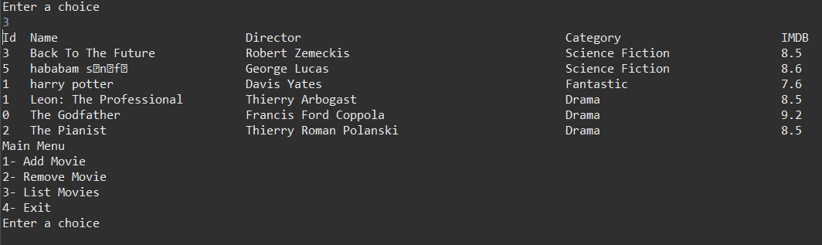

Paste a screenshot that aims to remove an item but cannot remove the item cause it does not exist. And print the list.

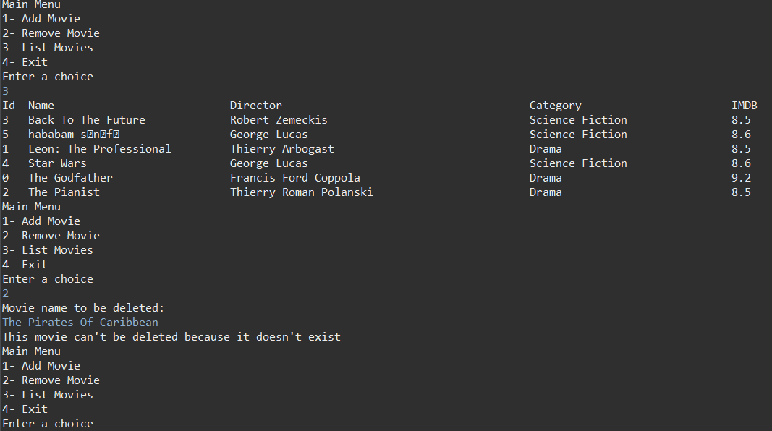

* Print all movies:

Paste the print code fragment(method or function) of your project.

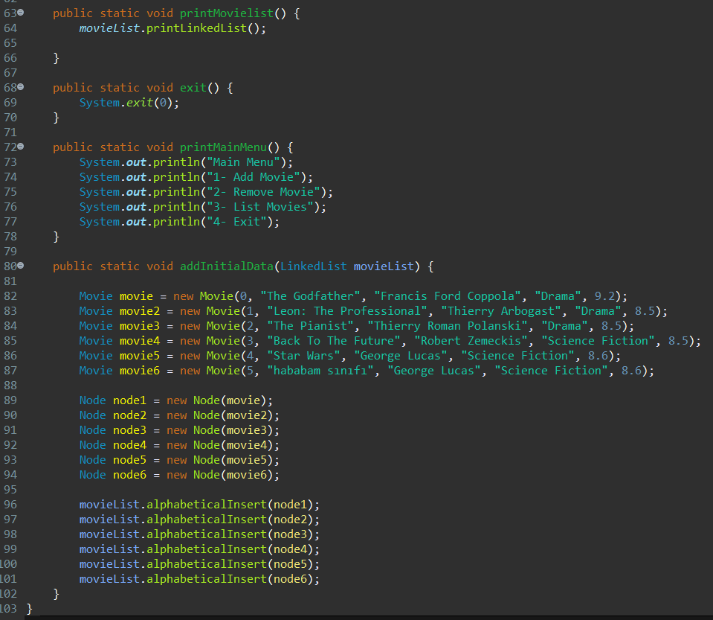

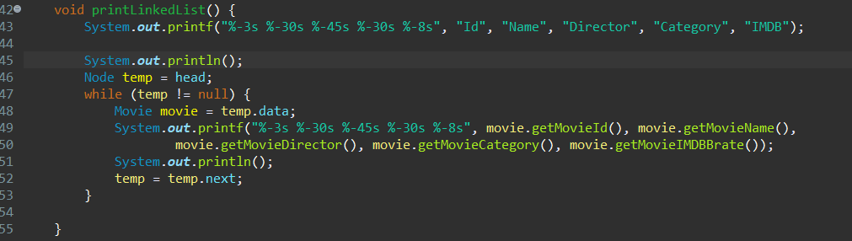

Paste a screenshot that prints all the elements from the first one to the last one (actually all previous screenshots do this. Anyway paste one more here).

